To: | Development Determination Panel
From: | Ashley Warnest  Planner
Date: | 26 May 2021
Subject: | DA2020/1697 - 28 Palmgrove Road AVALON BEACH

Dear Panel,

The applicant has provided amended plans to reflect the conditions imposed in Condition 7. The amended plans reduce the roof form of the first floor level deck, and reduce the first floor level privacy screening.
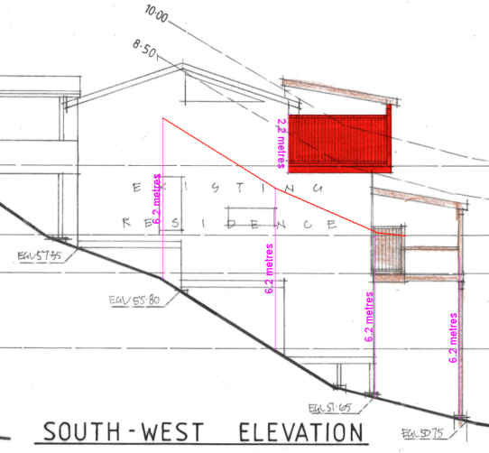
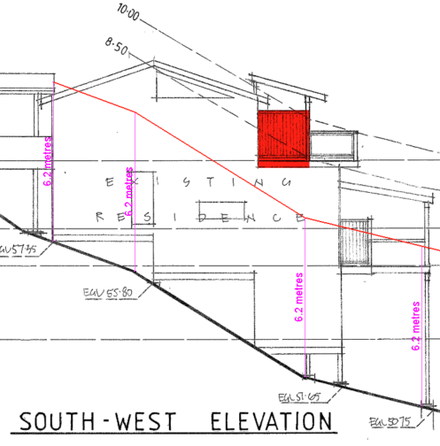
The amended plans result in an overall reduction in the extent of the building envelope variation as demonstrated below.
The first image is the original proposal and the second image is the amended plans.
The intention of the imposed conditions 7 a, b, c, and d was to minimise the visual bulk of the proposal. The amended plans address the intention of the imposed conditions 7 a, b, and c. Whilst the roof form has not been reduced in height it is consistent with the design of the existing roof form. The retention of the roof height is considered reasonable due to the reduction in the roof extent.
Council recommends conditions 7 a, b, and c to be deleted. Condition 7 (d) in regards to the maximum height of all privacy screens should be retainage to ensure built form is minimised.

Kind regards,
Ashley Warnest
Planner

